**Phase 2**

**Children Zoo Encyclopedia**

**Team Members:**

1. Hend Mohamed
2. Rowan Omar
3. Nour Fouad
4. Bishoy Hany

**Description:**

Children Zoo Encyclopedia is an entertainment game for children aged between 3~5 years for learning about the animal planet. The game will introduce to the child some interaction technique for creative learning. They will be able to drag animals to the places where they live; they can click on the animals to know their names, what they eat and where they live. The game also will help them know how to write animals’ names. Finally, for getting children attraction each animal will keep showing how they move.

* **User Tasks**
* T1: Play and Learn new things about animals and alphabets.
* T2: Put animals in their homes.
* T3: Feed the animals.
* T4: Form animal names.
* T5: Listen to animals sounds.
* T6: Learn how animals move.
* **Persona**

My name is Malak. I am 30 years old. I have a four years old girl. Most of time I am busy doing some work but my daughter keeps crying and bothers me. So, I needed something to get her attention while I finish my work. When I was asked about this game, I thought it was really a good idea to keep her busy as well as learning new things. She didn’t attend school yet, so if I had a chance to give her something to learn before school like alphabets, some animal names and things like that it would be perfect. Things with animations and sounds mostly attract my daughter’s attention. I want her to do something that gives her motivation toward learning and being success in the future.

* **Functional Requirements**

**Requirement #:** 0001

**Requirement Type:** Functional Requirement

**Description:** The system will allow the child to assign every animal to its home.

**Rationale:** Teach the children where different animals live.

**Source:** Yasmine Assy (A mother)

**Fit criterion:** Children will learn how to differentiate where every animal can live by assigning every animal to its home.

**Dependencies:** none

**Conflicts:** none

**Requirement #:** 0002

**Requirement Type:** Functional Requirement

**Description:** The system will allow the child to assign food to animals.

**Rationale:** Teach the children what different animals eat.

**Source:** Yasmine Assy (A mother)

**Fit criterion:** Children will learn how to differentiate what every animal can eat by assigning food to the right animal.

**Dependencies:** none

**Conflicts:** none

**Requirement #:** 0003

**Requirement Type:** Functional Requirement.

**Description:** The system will allow the child to click on animals to hear their names.

**Rationale:** Teach the children to recognize animals’ names.

**Source:** Mai elkassry (A mother)

**Fit criterion:** Children will learn how to spell and get familiar with names by hearing animals’ names.

**Dependencies:** none

**Conflicts:** none

**Requirement #:** 0004

**Requirement Type:** Functional Requirement.

**Description:** The system will allow the child to drag letters to places that form an animal’s name (puzzle).

**Rationale:** Teach the children to recognize animals’ names and letters.

**Source:** Nada Gamal (A mother)

**Fit criterion:** Children will learn how to form an animal’s name and know the shapes of letters by dragging the letter to its right place.

**Dependencies:** none

**Conflicts:** none

**Requirement #:** 0005

**Requirement Type:** Functional Requirement.

**Description:** The system can show to the child how animals move (Animations).

**Rationale:** Teach the children to recognize how animals move whether they fly, walk, climb, or swim.

**Source:** Mai Elkassry, yasmine Assy and Nada Gamal (mothers).

**Fit criterion:** Get children’s attention by creating animations.

**Dependencies:** none

**Conflicts:** none

* **Non-Functional Requirements**

**Fast:** Respond quickly to user interactions with silky smooth animations.

**Reliable:** Load instantly even in uncertain network conditions.

**Usable:** Easy to learn and effective to use.

* **Row collected data**

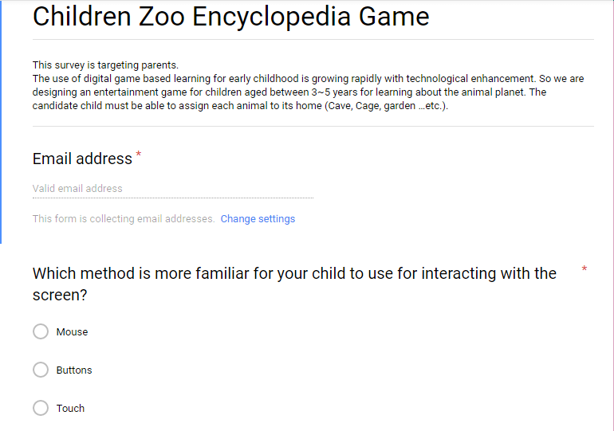

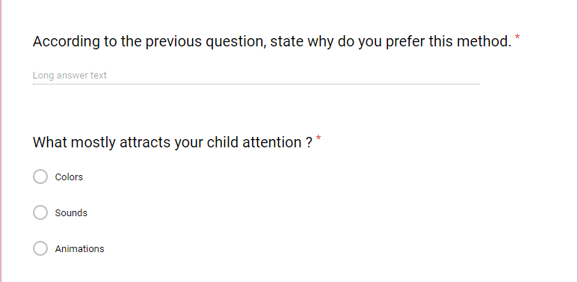

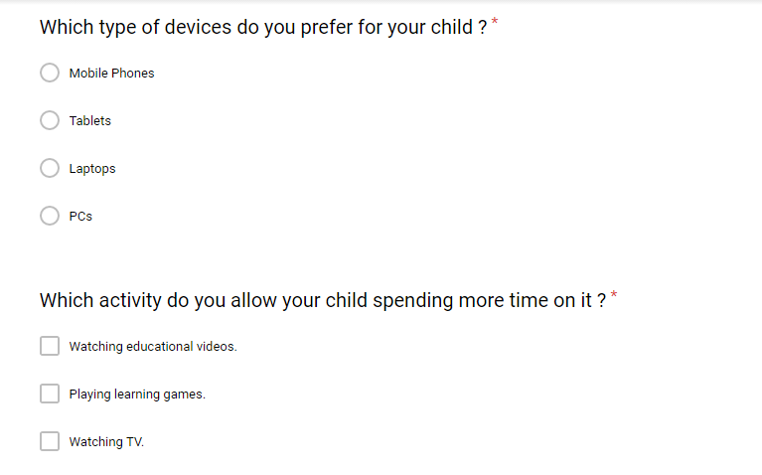

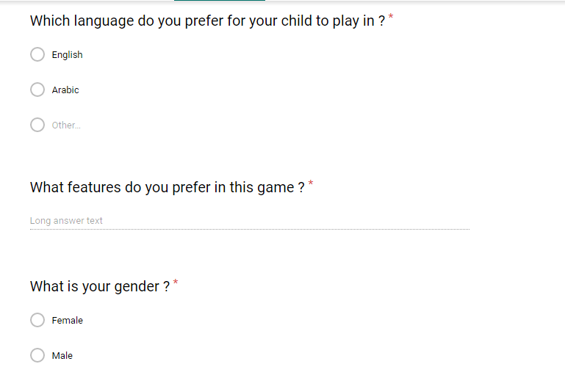



|  |  |  |  |  |
| --- | --- | --- | --- | --- |
| Timestamp | Username | Which method is more familiar for your child to use for interacting with the screen? | According to the previous question, state why do you prefer this method. | What mostly attracts your child attention? |
| 2017/09/28 10:52:34 AM GMT+2 | Radwasamym  @gmail.com | Touch | اسهل | Animations |
| 2017/09/28 11:04:34 AM GMT+2 | [taraggy.ghanim@miuegupt.edu.eg](mailto:taraggy.ghanim@miuegupt.edu.eg) | Touch | they prefer touch devices | Animations |
| 2017/09/28 11:19:31 AM GMT+2 | yasmine.assy@miuegypt.edu.eg | Touch | Easier for her. | Animations |
| 9/28/2017 14:22:19 | [mai.elkassry@gmail.com](mailto:mai.elkassry@gmail.com) | Touch | More easily | Animations |

|  |  |  |  |  |  |
| --- | --- | --- | --- | --- | --- |
| Which type of devices do you prefer for your child? | Which activity do you allow your child spending more time on it? | Which language do you prefer for your child to play in? | What features do you prefer in this game? | What is your gender? | What is your age? |
| Tablets | Playing learning games. | Arabic | graphics | Female | 20 - 30 |
| Laptops | Playing learning games. | Arabic | graphics and sound | Female | 30 - 40 |
| Tablets | Playing learning games. | English | know more about animals, what they eat, where they live and so on | Female | 30 - 40 |
| Tablets | Watching educational videos. | English | Learning | Female | 20 - 30 |

* **Scenarios**

1. **Activity Scenario:**

The child go through some levels to complete the game, the first one is to match each animal with its home, second level is to feed the animals; each is fed with the type of food that match it and then the learning part in which the child has to complete the name of each animal according to the shadings under each picture and to hear the sound of animals to learn their sounds and also to see their moves.

1. **Information Scenario:**

This application consists of five screens, the first with two icon so the child can choose whether he/she wants the game first or the learning part, if he/she chooses the game; the child will be directed to level one in which he/she can match each animal with the place it lives in and when he/she matches all the animals a notification appears indicating finishing this level and moving to level two which the child has to feed the animals. And if the child chooses the learning part, another menu will appear so he/she has to choose whether to direct the child to a screen in which he/she will able to learn animals names or another screen to learn their sounds and moves and when he/she finishes he/she can go back to maybe play again.

1. **Interaction Scenario:**

Firstly, the child has to choose from two buttons whether he wants to play the game or to learn, so, if the child clicked on the game button, the game would start. The first level, the child drags an animal and match it with its home. The second level, the child drags the food to animals to feed them. If the child clicked on the learning button, a modal would appear to choose whether to learn animals’ names or show animals moves. If the child clicked on the animals’ names button, the learning part would start and the child can drag the letters to match the shaded name of each animal to complete the animal’s name. If the child clicked on the animals’ moves button, he/she would be navigated to animals’ moves and sounds screen. He/ She can see how animals move and can hear their sounds by clicking on the sound icon.

Backward Connectedness:

* Child find animal’s home.
* Child feeds the animal.
* Child completes animal’s name.

Forward Connectedness:

* Child chooses to play the game or to learn.
* Child chooses to complete animals’ names or to hear their sounds and watch their moves.
* **Sketches**

Attached as separate pictures.

* **Storyboard**

Attached as separate PDF

* **Formative** **Evaluation**

We had two alternative sketches to take users’ feedback on them, the first one (refused sketch) was refused by most of the users as they see it was so crowded and put a lot of functionalities in one screen which may disturb their child’s attention. Also, they saw that children may not be familiar to how navigation bars are used. So, we made some modifications on the design and tried to make each screen focusing on a single functionality in order for the child to take the most benefit out of the system so, this sketch (Accepted sketch) was accepted by them.